RIDER
SARAH MACDOUGALL 2016

FOUR-PIECE BAND- GUITAR, KEYS, DRUMS, BASS

STAGE PLOT FOUR-PIECE SARAH MACDOUGALL

Sarah MacDougall live in concert requires a stereo, professional sound reinforcement system, with all components completely set-up, tested and in correct polarity with each other prior to the artists’ arrival. This system shall be in excellent working order, provide a flat frequency response, and be free of noise and distortion. The system must be adequately rated to provide even coverage and sound pressure level for the entire venue. Proper cabling must be supplied for all equipment listed below.

In some situations (festivals, installations), it is understood that substitutions of certain components and specifics may be unavoidable. Please ensure the artist and/or their production staff is consulted, and the overall requirements of this rider can be met.

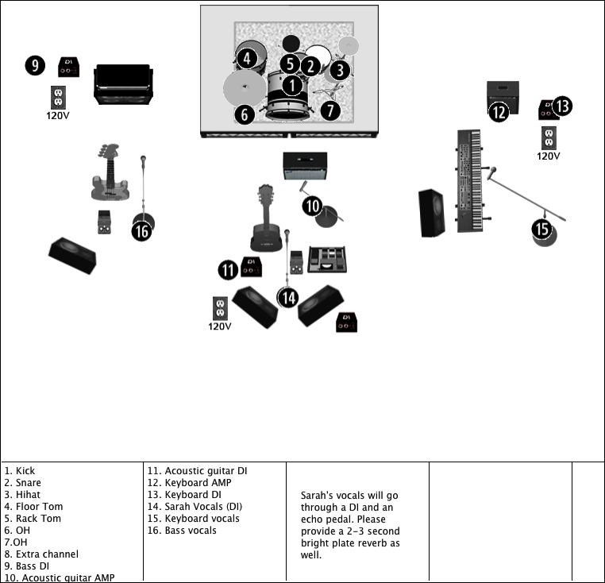

NOTES
- Good working monitors are a necessity, performance cannot happen without them
- 1-2 monitors are acceptable at center guitar position
- Mic stands must be ‘boom’ type stands
- Please ring out feedback from monitors prior to artist load in
- Please provide space to store empty cases

PLEASE ALLOW AT LEAST 60 MINS FOR SOUNDCHECK, NOT INCLUDING LOAD-IN AND SETUP. ARTIST USES LOOPING EFFECTS WHICH CAN TAKE SOME TIME TO CHECK PROPERLY.

“FESTIVALS CAN BE AN EXCEPTION DEPENDING ON THE CIRCUMSTANCE. “

All changes must be cleared with Sean Russell (Manager)
sean@baselinemusic.ca
Office: 647 722 6272
Cell: 647 808 2263

Lighting: Please provide coloured, ‘moody’ lighting on stage. Please, no bright white lights.

HOSPITALITY FOUR-PIECE SARAH MACDOUGALL

Accommodation: 4x single rooms. (2x double is ok)

Food: Please provide 4x healthy meals or a buy-out. Buyout preferred, as people in the band have various dietary needs.

Meal suggestions: Meat/Fish/Chicken w/rice & steam veggies & baked potato, curry’s, Sushi, CURRY, Salad with meat/tofu/nuts.

Dressing room: Please provide a warm green room area for the artists.

Important Green Room items:
8x bottles or glasses of water.
Herbal tea (pref. peppermint or throat coat)
Kettle and water for the kettle
Towel

Always nice:
1 bottle of red wine to shar.
Selection of fruit/Veggies/healthy snacks
Fishermans friends (originals)
A glass of scotch after the show if the artist is up for it. : )

The hospitality rider and a welcoming and helpful promoter and staff are all an essential part of the artist putting on the best show possible. We would like to thank you for inviting us to perform at your venue.

If you have any questions or concerns about ANY changes to the above rider, please feel free to contact:

Sean Russell (Manager)
sean@baselinemusic.ca
Office: 647 722 6272
Cell: 647 808 2263

